**DESIGN OVERVIEW**

1. **Design Framework and Architecture:**

* The project follows a clean, modular structure with separate HTML files for different sections
* Uses vanilla HTML, CSS, and JavaScript without heavy frameworks, focusing on performance and simplicity
* Implements a responsive design approach with mobile-first considerations

1. **UI Components and Layout:**

* Modern navigation system with a responsive menu
* Hero section with prominent imagery
* Card-based layouts for programs, mentors, and resources
* Gradient accents and modern color scheme
* Responsive grid systems for content organization

1. **Design Elements:**

* Color Scheme:
  + Primary background: Dark theme (#081b29)
  + Accent colors: #009FFF (blue) and #ec2F4B (red)
  + Text color: #ededed (light gray)
  + Uses gradients for visual interest
* Typography:
  + Poppins font family for clean, modern readability
  + Responsive font sizing using rem units
  + Hierarchical typography system

1. **External Plugins and Libraries:**

* Boxicons (v2.1.1) for modern, scalable icons
* No heavy JavaScript frameworks, keeping the site lightweight
* Custom JavaScript for interactive features

1. **Responsive Design Features:**

* Fluid layouts using CSS Grid and Flexbox
* Multiple breakpoints for different screen sizes:
  + Mobile optimization below 576px
  + Tablet optimization at 800px
  + Desktop-first approach with graceful degradation

1. **Special Features:**

* Smooth scroll behavior
* Interactive navigation with active state indicators
* Card-based UI components with hover effects
* Semi-transparent overlays for depth
* Gradient buttons and accents for visual interest

1. **Performance Considerations:**

* Optimized image assets in the assets folder
* Modular CSS organization
* Minimal external dependencies
* Efficient CSS selectors and specificity

1. **Accessibility Features:**

* Semantic HTML structure
* Proper heading hierarchy
* ARIA-friendly navigation
* High contrast color scheme
* Responsive text sizing

The design follows modern web development best practices while maintaining a clean, professional aesthetic suitable for an educational platform. The use of gradients, cards, and interactive elements creates an engaging user experience while maintaining functionality and performance.

**File Structure**

**HTML Files**

* **index.html**: Main landing page with hero section
* **about.html**: Information about the initiative
* **programs.html**: Available programs and courses
* **stories.html**: Success stories and testimonials
* **mentors.html**: Mentor profiles and information
* **enrollment.html**: Registration and enrollment details
* **resources.html**: Learning resources and materials
* **contact.html**: Contact form and information

**Assets Directory**

Contains all image assets used throughout the site:

* Hero section images
* Mentor profile pictures

**Styles Directory**

Contains a single **style.css** file (approximately 1,500+ lines)

**JavaScript**

* **script.js**: Handles all interactive functionality

**Why Styles Weren't Modularized**

**Time Constraints**

The decision to keep all styles in a single CSS file was primarily due to time limitations during development. Here's why:

1. **Project Deadline Priority**
   * Meeting the project deadline was the primary concern
   * Implementing core functionality and responsive design took precedence
   * Single CSS file allowed for faster development and testing
2. **Development Workflow**
   * Quick iterations and changes were easier with one file
   * No need to switch between multiple files during rapid development
   * Faster debugging during the development phase
3. **Style Organization** Despite being in a single file, the CSS is organized into logical sections:

* /* Global Styles */
* /* Header Styles */
* /* Navigation Styles */
* /* Hero Section */
* /* Program Cards */
* /* Mentor Profiles */
* /* Contact Form */
* /* Media Queries */

**Future Improvements**

If time permits, the CSS could be modularized into:

* **base.css** for global styles
* **components.css** for reusable components
* **layout.css** for structural elements
* **pages/** directory for page-specific styles
* **utilities.css** for helper classes
* **responsive.css** for media queries

**PAGES STRUCTURE**

**1.Common Elements**

* **Every page contains:**
* **Header with:**
  + **CyberGirls logo (with gradient span)**
  + **Responsive hamburger menu icon**
  + **Navigation bar with links to all sections**
  + **Gradient "Contact Us" button**
* **Footer with:**
  + **Organization information**
  + **Program links**
  + **Resource links**
  + **Contact details**
  + **Social media icons**

**2.Page-Specific Structures**

1. **Home Page (index.html)**

* **Hero section with:**
  + **Split layout (content and image)**
  + **Main heading with gradient accent**
  + **Subheading about cybersecurity**
  + **Mission paragraph**
  + **Social media icons**
  + **Two CTA buttons (Enroll and Contact)**
  + **Circular hero image**

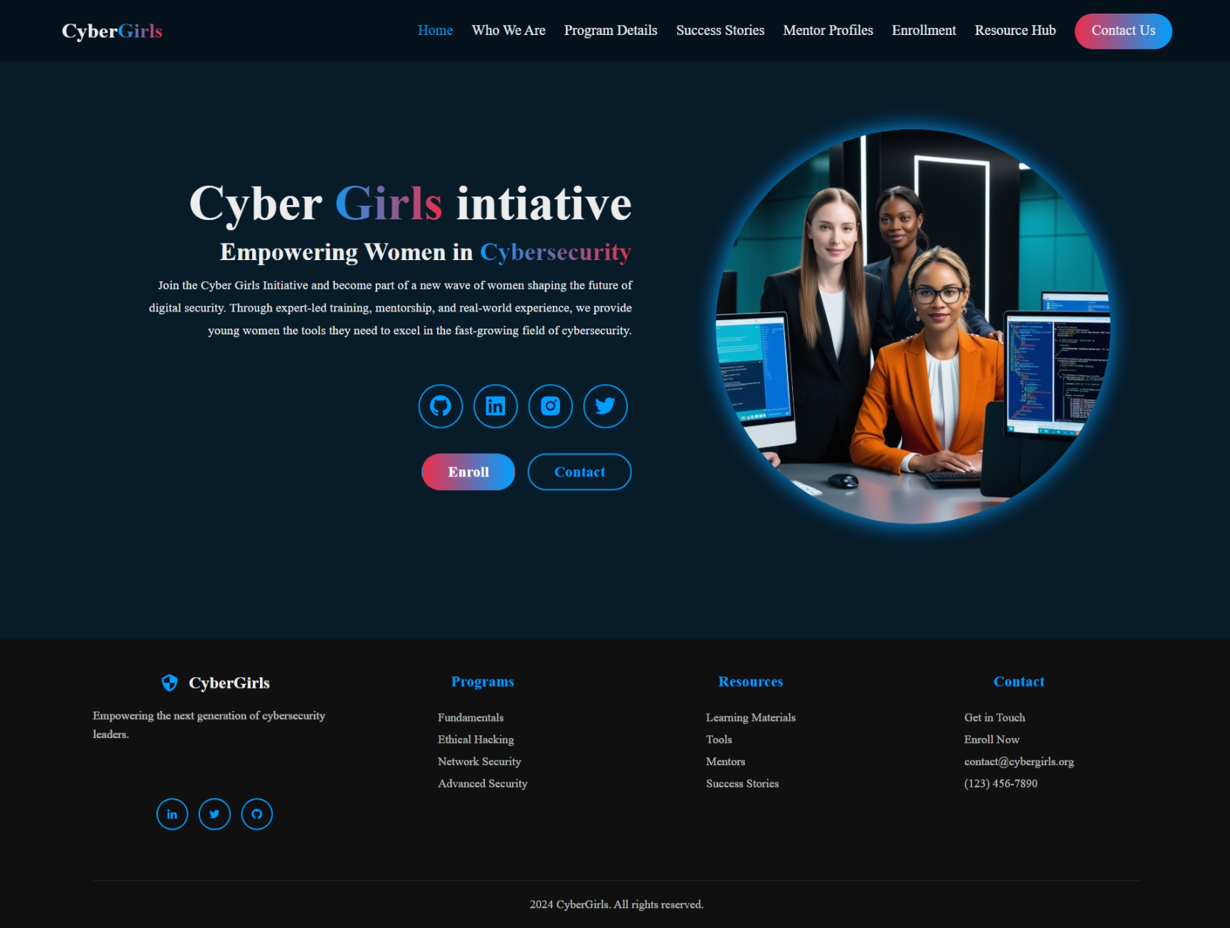

1. **About Page (about.html)**
   * + **"Who We Are" section containing:**

* **Main heading**
* **Mission and Vision statements**
* **Core values**
* **Organization description**

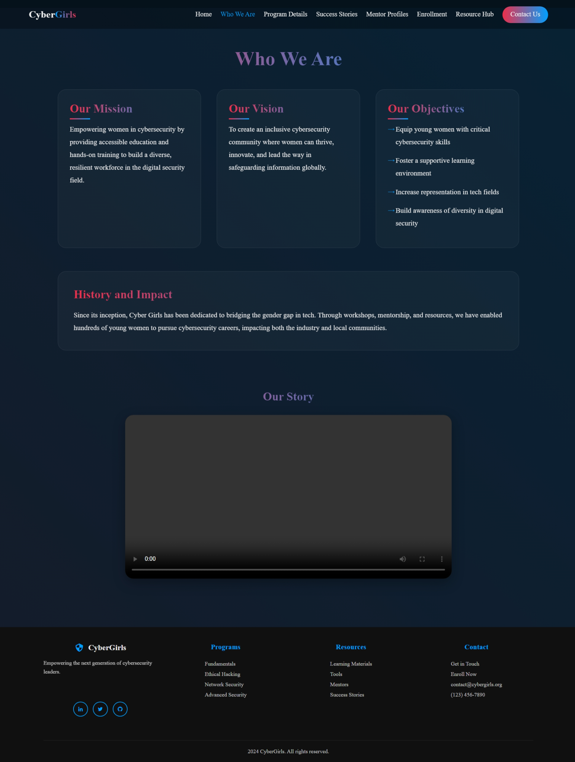

1. **Programs Page (programs.html)**

* **Program offerings section with:**
  + **Course listings**
  + **Program descriptions**
  + **Training details**

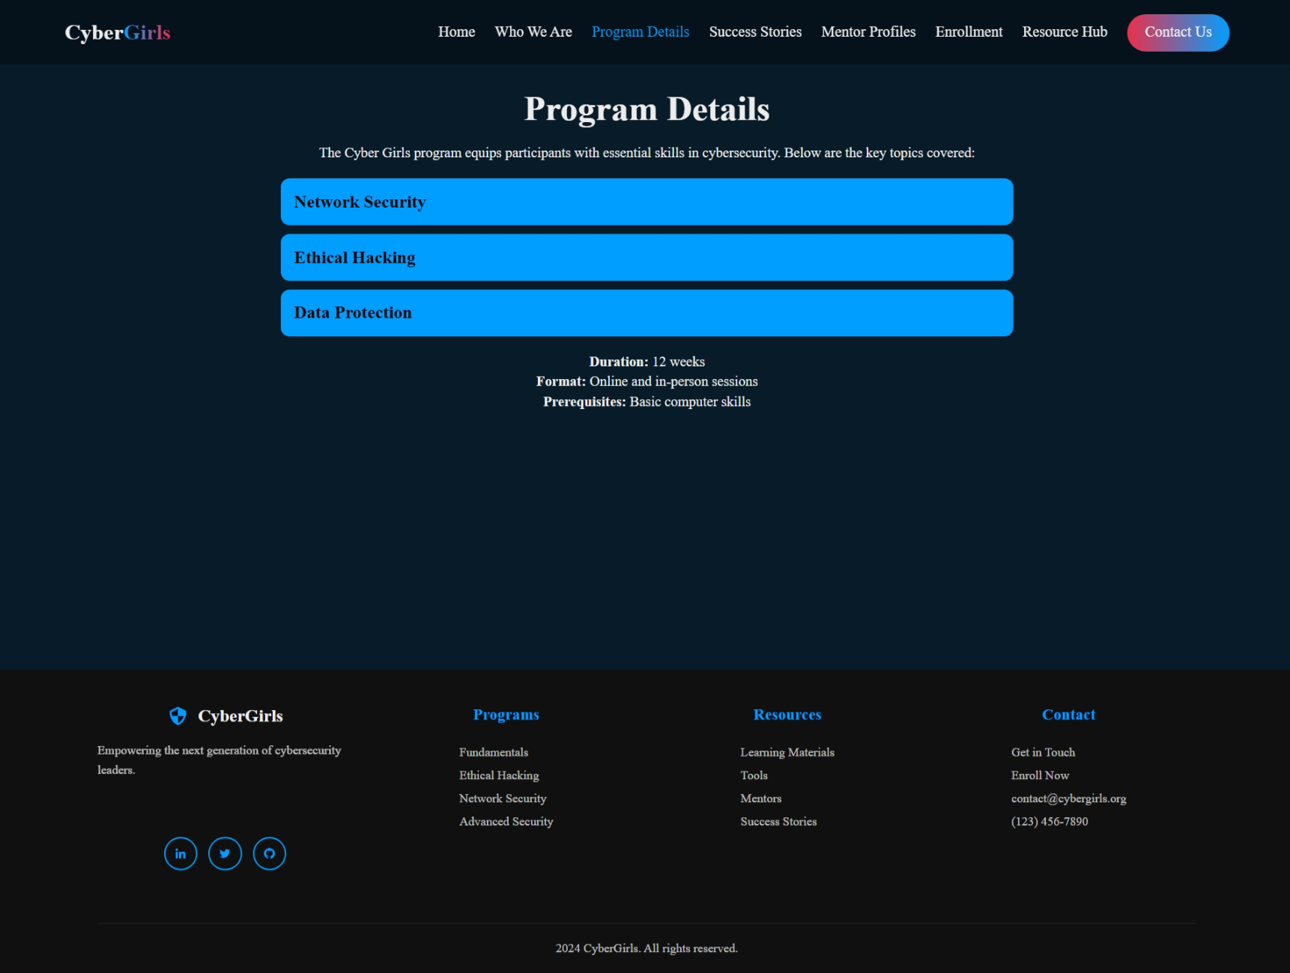

1. **Stories Page (stories.html)**

* **Success stories section featuring:**
  + **Student testimonials**
  + **Achievement highlights**
  + **Impact stories**

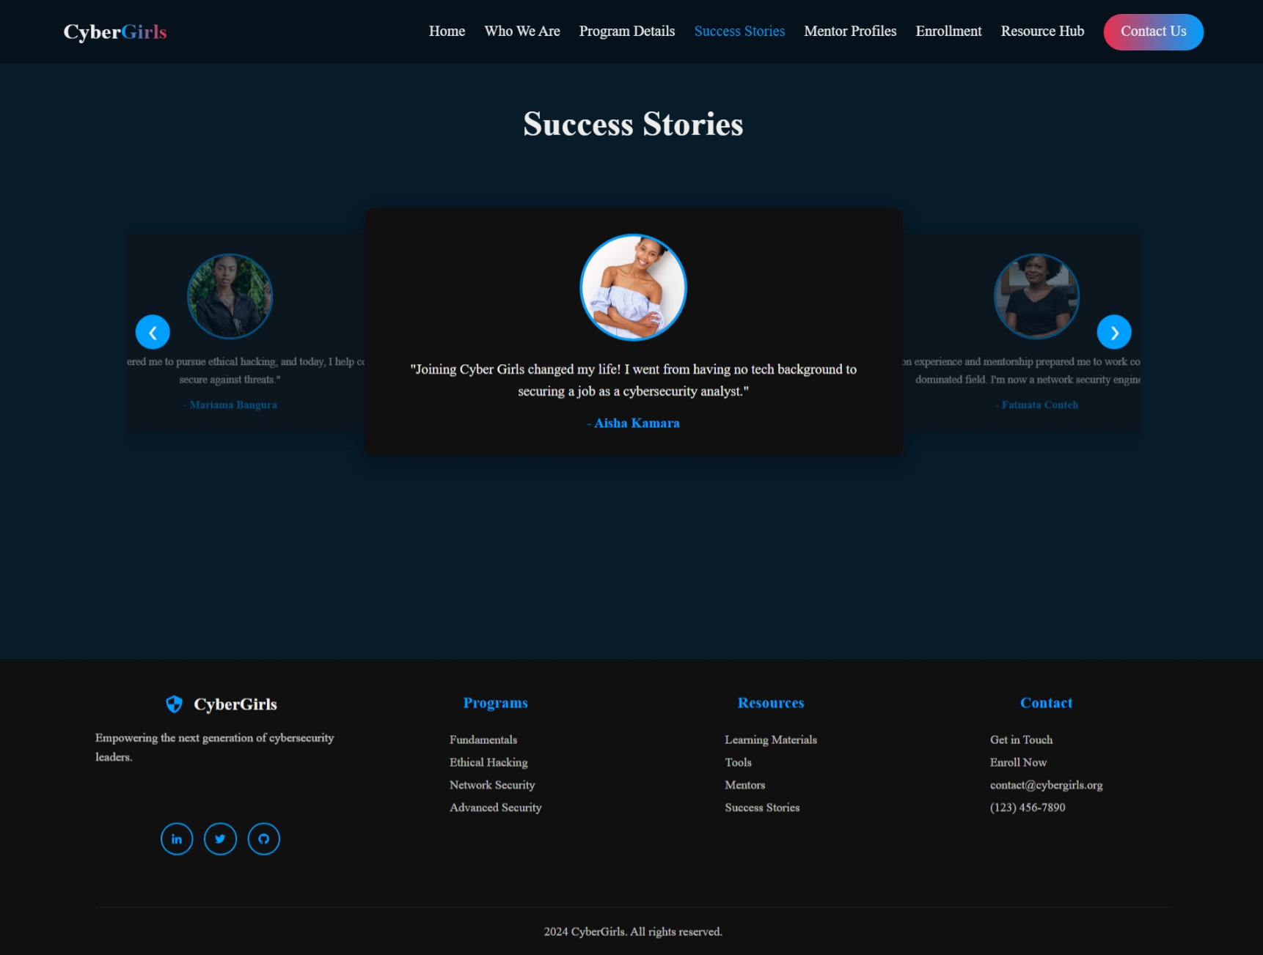

1. **Mentors Page (mentors.html)**

* **Mentor profiles section with:**
  + **Mentor information**
  + **Expertise areas**
  + **Professional backgrounds**

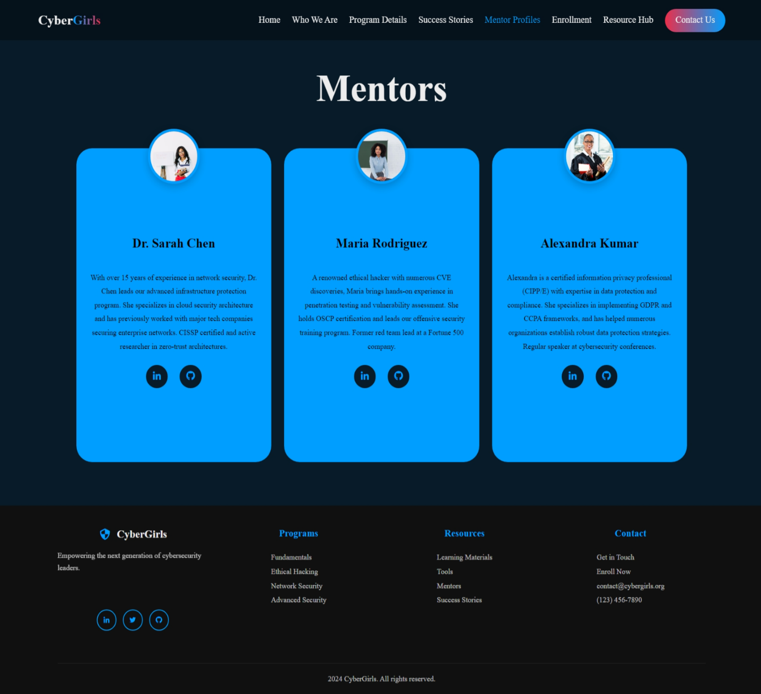

1. **Enrollment Page (enrollment.html)**

* **Enrollment section containing:**
  + **Registration information**
  + **Program selection**
  + **Application process**

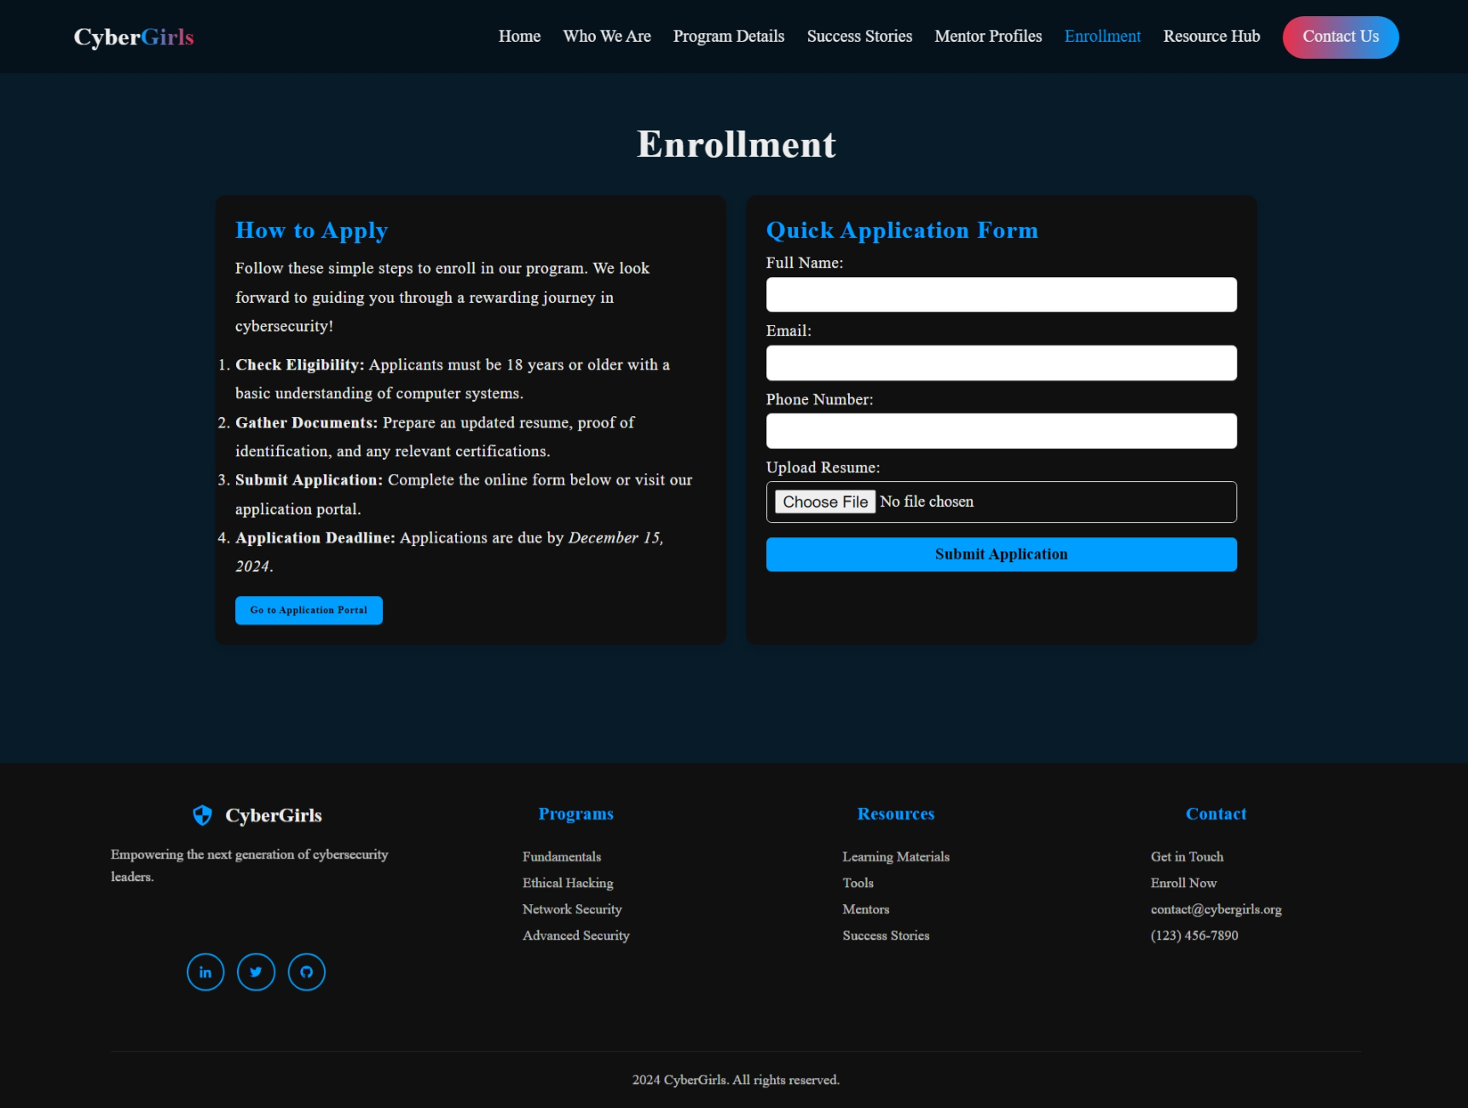

1. **Resources Page (resources.html)**

* **Resource hub with:**
  + **Learning materials**
  + **Tools and resources**
  + **Educational content**

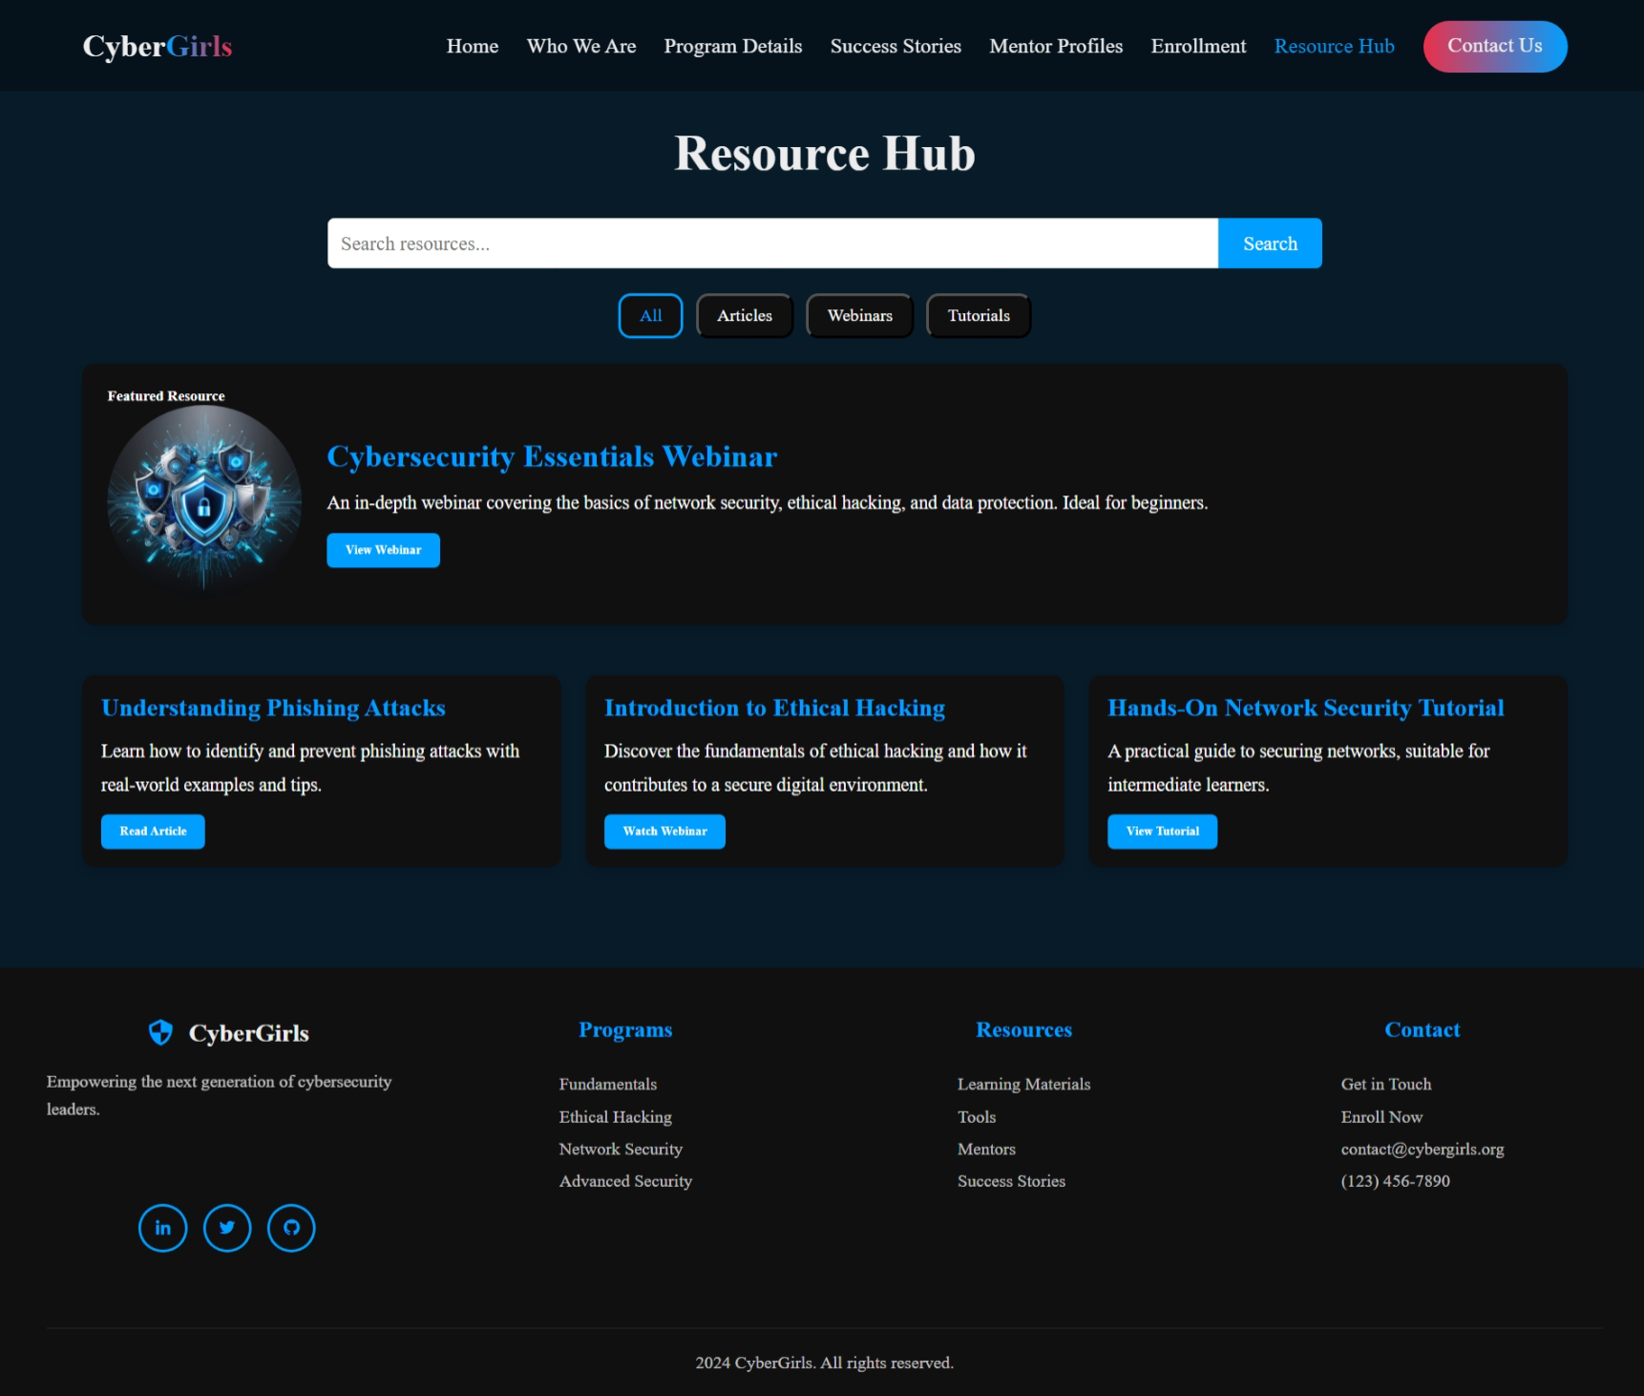

1. **Contact Page (contact.html)**

* **Contact section featuring:**
  + **Contact information**
  + **Communication channels**
  + **Get in touch options**

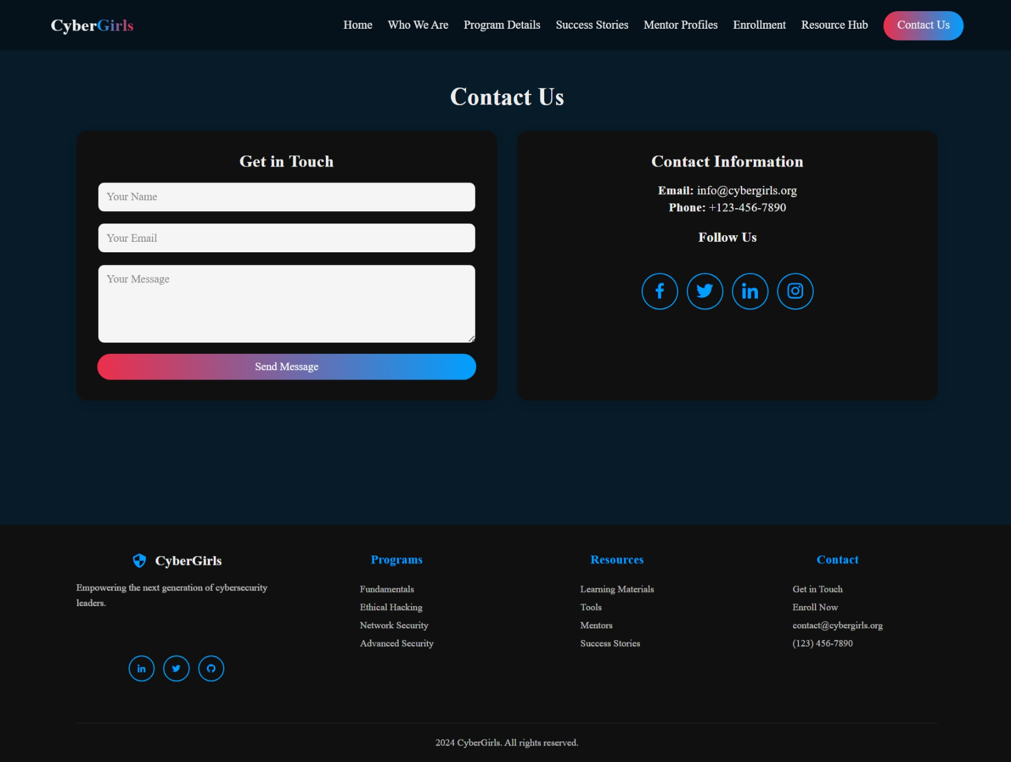

**3.Technical Structure**

* **All styles contained in single style.css file**
* **JavaScript functionality in script.js**
* **Images stored in assets directory**
* **Boxicons used for icons**
* **Responsive design implementation**
* **Dark theme with gradient accents**

**4.Navigation Structure**

* **Home**
* **Who We Are (About)**
* **Program Details**
* **Success Stories**
* **Mentor Profiles**
* **Enrollment**
* **Resource Hub**
* **Contact Us (with gradient button)**

**This structure maintains consistency across all pages while allowing each section to serve its specific purpose in the organization's online presence.**